INTERNSHIP REPORT

CODEC TECHNOLOGIES

VIRTUAL INTERNSHIP 2026
Submitted by

MONISHA S
[2114242430274]

BACHELOR OF TECHNOLOGY
in

ARTIFICIAL INTELLIGENCE AND DATA SCIENCE
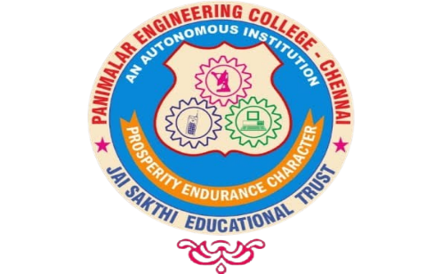

PANIMALAR ENGINEERING COLLEGE
An Autonomous Institution,
Affiliated to Anna University, Chennai
JUNE 2026

BONAFIDE CERTIFICATE

This is to certify that the internship report titled “CODEC TECHNOLOGIES VIRTUAL INTERNSHIP 2026” is the bonafide work of “MONISHA S [2114242430274]” who successfully carried out the Internship at CODEC TECHNOLOGIES and AICTE.

Signature of the Mentor  Dr.M.VIDHYASREE M.E., (Ph.D).,  ASSISTANT PROFESSOR,  Department of Artificial Intelligence  and Data Science,  Panimalar Engineering College,  Chennai – 123. | Signature of the Internship Coordinator  Mrs. J. ANITHA M.E., (Ph.D).,  ASSISTANT PROFESSOR,  Department of Artificial Intelligence  and Data Science,  Panimalar Engineering College,  Chennai – 123.

Certified that the above candidate(s) was examined in the End Semester Internship Viva-Voce Examination held on …………………

DECLARATION

I, MONISHA S [2114242430274] hereby declare that this internship report titled “CODEC TECHNOLOGIES VIRTUAL INTERNSHIP 2025” completed through the codec technologies and AICTE, is my original work.
I affirm that this report has not been plagiarized, nor has it been submitted previously to any other institution or organization for any academic or professional purpose.

` MONISHA S

ACKNOWLEDGEMENT

Our profound gratitude is directed towards our esteemed Secretary and Correspondent,
Dr. P. CHINNADURAI, M.A., Ph.D., for his fervent encouragement. His inspirational support proved instrumental in galvanizing our efforts, ultimately contributing significantly to the successful completion of this Internship.

I want to express my deepest gratitude to our Directors, Tmt. C. VIJAYARAJESWARI, Dr. C. SAKTHI KUMAR, M.E., Ph.D., and Dr. SARANYASREE SAKTHIKUMAR, B.E., M.B.A., Ph.D., for graciously affording us the essential resources and facilities for undertaking of this Internship. My gratitude is also extended to our principal Dr. K. MANI, M.E., Ph.D., whose facilitation proved pivotal in the successful completion of this Internship.

I express my heartfelt thanks to Dr. S. MALATHI, M.E., Ph.D., Head of the Department of Artificial Intelligence and Data Science and Dr. A. JOSHI, M.E., Ph.D., for granting the necessary facilities that contributed to the timely and successful completion of Internship. I would like to express our sincere thanks to our Internship Co-Ordinator, Mrs. J. ANITHA M.E.,(Ph.D)., and Mentor Dr.M.VIDHYASREE M.E., (Ph.D)., all the faculty members of the Department of AI&DS for their unwavering support for the successful completion of the Internship.

MONISHA S

TABLE OF CONTENT

CHAPTER NO. TITLE PAGE NO.
- ABSTRACT 6
- COMPANY PROFILE 7
- COMPANY CERTIFICATE 8
- INTRODUCTION 9
- INTERNSHIP OVERVIEW 10
- PROJECT DETAILS 11
- PROJECT DEVELOPMENT 13
- CHALLENGES FACED 15
- PROBLEM SOLVING & 16
DEBUGGING
- TESTING & DEBUGGING 17
- CONCLUSION 18

12. ANNEXURE 19

ABSTRACT

This internship was completed at Codec Technologies under the AICTE & ICAC Approved Internship Program through the National Internship Portal. The internship focused on Graphic Designing, where I gained practical experience in creating digital designs, promotional materials, and visual content using modern design tools. Throughout the one-month internship (01 June 2026 to 30 June 2026), I developed skills in color theory, typography, layout design, branding, and creative problem-solving. The program also improved my communication, teamwork, and time management abilities while providing valuable industry exposure. Overall, this internship strengthened my technical and creative skills and enhanced my confidence to work on real-world graphic design projects in a professional environment.

COMPANY PROFILE

Codec Technologies Pvt. Ltd. is a technology-driven company specializing in software development, IT consulting, and industry-oriented training programs. The company is committed to bridging the gap between academic learning and industry requirements by providing students with practical knowledge and real-world experience. Codec Technologies offers internships and training in various domains, including Graphic Designing, Web Development, Artificial Intelligence, Data Science, Cloud Computing, Digital Marketing, and Software Development. With a strong focus on innovation, creativity, and technical excellence, the company equips learners with the skills needed to succeed in today's competitive professional environment.
Codec Technologies Pvt. Ltd. collaborates with organizations such as the All India Council for Technical Education (AICTE) and the National Internship Portal (NIP) to deliver industry-recognized internship programs. Through structured training, expert mentorship, and hands-on project work, the company provides students with opportunities to apply theoretical concepts in practical scenarios. These programs help participants enhance their technical knowledge, communication skills, teamwork, and problem-solving abilities while preparing them for future careers.
Together, The company believes in continuous learning, innovation, and quality education. By offering project-based training and exposure to modern technologies, Codec Technologies enables students to develop confidence and gain valuable industry experience.

COMPANY CERTIFICATE

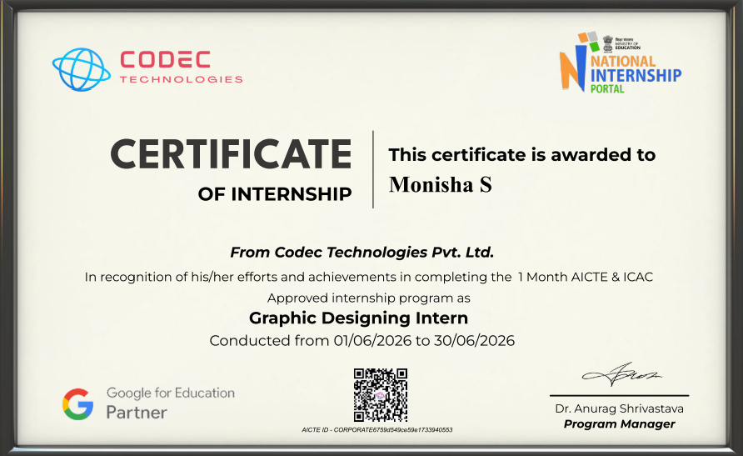

INTRODUCTION

About the Internship
The internship focused on developing creative and technical skills in graphic design. It included hands-on training in designing posters, banners, social media creatives, logos, and other digital content.
Objectives of the Internship
- To develop practical skills in graphic designing.
- To understand design principles, branding, and visual communication.
- To gain real-world industry experience through project-based learning.
Duration and Mode
The internship was conducted from 01 June 2026 to 30 June 2026 for a duration of one month. It was carried out in online mode, allowing flexible learning and project completion.
Eligibility and Participants
The internship was open to students interested in graphic design and digital creativity. Basic computer knowledge and a willingness to learn design tools were the primary requirements.
Internship Role and Responsibilities
As a Graphic Designing Intern, my responsibilities included creating digital graphics, designing promotional materials, applying design principles, and completing assigned creative tasks within the given timeline.

INTERNSHIP OVERVIEW

Duration and Timeline
The internship was conducted for one month, from 01 June 2026 to 30 June 2026. The training followed a structured schedule with regular learning sessions and project submissions.
Mode of Internship
The program was delivered 100% virtually, providing flexibility for participants across India to engage remotely using the ServiceNow Now Learning Platform. Students accessed live training, webinars, interactive labs, and certification preparation materials online.
Number of Participants
The The internship included students from different colleges and disciplines across India. It provided a collaborative learning environment where participants gained industry-oriented skills.
Key Learning Components
- Graphic design principles and visual communication
- Color theory and effective color combinations.
- Poster, banner, and brochure designing.
- Reporting, analytics, and performance dashboards
- Image editing and photo enhancement.
Objective Summary
The main objective was to enhance creative and technical skills in graphic designing while providing practical industry exposure. The internship also aimed to improve communication, teamwork, problem-solving, and project management skills.

PROJECT DETAILS

Project Title
Social Media Promotional Poster Design
Project Objective
The objective of this project was to design an attractive and professional social media poster that effectively promotes a product or event while maintaining brand identity and visual appeal.
Project Description
The project focused on designing a professional social media promotional poster for a product or event. The main objective was to create an attractive design that effectively communicated the intended message. The design process began with planning the layout and selecting a suitable color palette. Appropriate fonts and typography were chosen to improve readability and visual appeal. High-quality images, icons, and graphics were incorporated to enhance the overall design. Branding elements such as logos and theme colors were included to maintain a consistent identity.
The poster was designed using professional graphic design tools while following standard design principles. Care was taken to ensure proper alignment, spacing, and visual hierarchy throughout the design. The completed poster was reviewed and refined based on feedback to improve its quality.

Tools and Technologies Used
- Canva / Adobe Photoshop
- Color theory and typography
- Image editing and background removal
- Layout design and branding
- Reporting and Performance Analytics tools
Key Responsibilities
- Planned the poster layout and selected suitable colors.
- Designed creative visuals and arranged text effectively.
- Edited images and added branding elements.
- Participating in hackathons and collaborative problem-solving sessions

Outcome
The final poster successfully met the project requirements by delivering a visually appealing and informative design. The project improved my creativity, design skills, and understanding of professional graphic design practices.

PROJECT DEVELOPMENT

Project Development
The project was developed by following a structured design process, including planning, concept creation, designing, reviewing, and finalizing the visual content based on project requirements.
Platform Setup and Configuration
The required graphic design software, fonts, templates, and design resources were installed and configured. The workspace was organized to ensure smooth and efficient project execution.
Design Process
Creative designs were developed using design principles such as color theory, typography, balance, contrast, and alignment. Multiple design concepts were created and refined based on feedback.
Branding and Content Development
Logos, posters, banners, brochures, and social media graphics were designed while maintaining a consistent brand identity through suitable colors, fonts, and layouts.
Reporting and Analytics
The completed designs were evaluated for creativity, readability, visual appeal, and overall effectiveness. Feedback was incorporated to improve the quality of the final output.
Testing and Validation
The designs were checked for proper alignment, image quality, resolution, spelling, and compatibility across different digital platforms before final submission.
Challenges and Resolution
Challenges such as selecting suitable color combinations, arranging layouts, and maintaining design consistency were resolved through experimentation, mentor guidance, and continuous improvement.
Capstone Project Implementation
The final project involved designing a complete promotional campaign, including a logo, poster, and social media creatives. The project demonstrated the practical application of graphic design principles and successfully met the specified objectives.

Challenges Faced
Challenges Faced
During the Graphic Designing Internship, I faced several challenges that contributed to my learning and professional growth. Initially, understanding design principles such as color theory, typography, and layout composition required continuous practice. Selecting appropriate fonts, color combinations, and visual elements while maintaining creativity and brand consistency was also challenging
Learning Platform Navigation
Understanding the fundamentals of graphic design, including color theory, typography, layout composition, and visual hierarchy, required continuous practice. Applying these principles effectively in real-world designs was initially challenging but improved through regular assignments and mentor guidance.
Creative Design Development
Creating visually appealing posters, logos, banners, and social media graphics while maintaining originality and brand consistency was a major challenge. Multiple design revisions and feedback helped enhance creativity and design quality.
Design Tool Proficiency
Learning to use professional graphic design software and its advanced features required time and consistent practice. Mastering tools for image editing, vector graphics, and layout design significantly improved my technical skills.
Time Management
Balancing internship assignments with academic responsibilities required proper planning and effective time management. Completing creative projects within deadlines helped improve my organizational and productivity skills.
Feedback and Collaboration
Understanding and implementing mentor feedback was essential for improving the quality of my designs. Regular communication and continuous revisions helped me develop a more professional approach to graphic designing.
Design Optimization and Quality Assurance
Ensuring that designs were visually appealing, high in quality, and suitable for different digital platforms was challenging. Careful review, testing, and optimization helped deliver professional and user-friendly graphic designs.

Problem-Solving and Debugging

Throughout the internship, problem-solving and design refinement played a vital role in creating professional and visually appealing graphic designs. Each project required careful planning, creativity, and continuous improvements to meet design standards and project objectives.
Debugging Tools Utilized
I extensively used graphic design tools such as Canva and Adobe Photoshop to create and edit posters, logos, banners, and social media graphics. These tools helped me adjust layouts, improve image quality, enhance typography, apply color corrections, and create visually engaging designs.
Problem Solving Approach
I approached design challenges by dividing each project into smaller tasks such as planning the layout, selecting colors, choosing fonts, and arranging visual elements. Feedback from mentors was carefully analyzed, and multiple revisions were made until the final design met the required quality standards.
Common Debugging Scenarios
  - Selecting suitable color combinations for better visual appeal.
  - Choosing readable and attractive fonts.
  - Ensuring proper alignment, spacing, and layout balance.
  - Optimizing images for high-quality digital display.
Lessons Learned
This hands-on experience improved my creativity, analytical thinking, and attention to detail. I learned the importance of planning, continuous practice, incorporating feedback, and reviewing designs thoroughly before final submission. The internship also strengthened my confidence in using professional graphic design tools and solving real-world design challenges effectively.

Testing & Debugging

Testing and debugging were essential parts of the graphic design project development process, ensuring that every design met quality standards and project requirements. Each design was carefully reviewed to identify errors, improve visual appeal, and maintain consistency before final submission.
Testing Approach
- Reviewed designs for alignment, spacing, and layout consistency.
- Verified typography, color combinations, and image quality.
- Checked spelling, grammar, and overall content accuracy.
- Ensured designs were compatible with different digital platforms.
- Collected mentor feedback and made necessary improvements.
Debugging During Testing
Whenever issues such as poor alignment, incorrect colors, low-resolution images, or inconsistent layouts were identified, they were corrected using graphic design tools. Multiple revisions were performed to refine the design and achieve a professional appearance.
Manual Validation
Each completed design was manually inspected to ensure visual balance, readability, branding consistency, and overall presentation quality. Designs were also tested on different screen sizes to ensure proper display and usability.
Outcome
The testing and debugging process helped produce high-quality, error-free designs that met project objectives. It improved my attention to detail, problem-solving abilities, and understanding of professional design standards, enabling me to deliver visually appealing and effective graphic content.

CONCLUSION

The Graphic Designing Internship at Codec Technologies Pvt. Ltd. was a valuable learning experience that enhanced my creative, technical, and professional skills. The internship provided practical exposure to real-world graphic design projects and helped me understand the importance of visual communication, branding, and effective design principles. It successfully bridged the gap between classroom learning and industry practices.
Throughout the internship, I gained hands-on experience in designing posters, logos, banners, brochures, and social media creatives using professional graphic design tools. I learned to apply concepts such as color theory, typography, layout design, and visual hierarchy to create attractive and meaningful designs. Continuous practice and mentor feedback helped improve the quality of my work.
The internship also strengthened my problem-solving, time management, communication, and teamwork skills. Working on multiple assignments within deadlines taught me how to manage projects efficiently while maintaining creativity and attention to detail. Overcoming design challenges increased my confidence in handling professional graphic design tasks.
Overall, this internship served as an excellent platform for developing both technical and personal skills. The knowledge and practical experience gained during the program have prepared me for future academic projects and career opportunities in the field of graphic design. I am confident that the skills acquired through this internship will contribute significantly to my professional growth and future success.

ANNEXURE - I
INTERNSHIP REPORT ROAD MAP
NAME OF THE STUDENTS |  |  | REGISTER NUMBER
MONISHA S |  |  | 2114242430274
NAME OF THE MENTOR: DR.M.VIDYASREE.M.E,(ph.D)
DEPARTMENT: ARTIFICIAL INTELLIGENCE AND DATA SCIENCE
1 | TITLE OF THE INTERNSHIP | Graphic Designing Internship – Codec Technologies Pvt. Ltd.
2 | OBJECTIVE | - To gain practical knowledge of graphic design principles and visual communication.  - To develop creative skills in designing logos, posters, banners, brochures, and social media graphics using professional design tools.
3 | MODULES SPLIT UP OR METHODOLOGY | - Module 1 – Introduction to Graphic Design and Design Principles.  - Module 2 – Color Theory, Typography, and Layout Design.  - Module 3 – Logo Design, Branding, and Social Media Graphics.  - Module 4 – Poster Design, Image Editing
4 | TOOLS AND TECHNIQUES | - Canva and Adobe Photoshop.  - Color Theory, Typography, Layout Design, and Visual Hierarchy.  • Branding, Logo Design, Poster Design, and Image Editing.  • Design Review, Feedback Analysis, and Quality Validation.
5 | OUTCOMES | - Developed practical skills in creating professional digital designs and branding materials Completion of 8-week virtual internship under AICTE–ServiceNow–SmartBridge academic program, with CSA exam readiness and enhanced employability in ITSM roles.
6 | SUSTAINABLE DEVELOPMENT GOALS MAPPED | - SDG 4 – Quality Education: Enhanced creative and technical skills through practical training in graphic design tools, design principles, and visual communication techniques.  - SDG 8 – Decent Work and Economic Growth: Developed industry-relevant graphic design skills that improve career opportunities in digital media, branding, and creative industries.  - SDG 9 – Industry, Innovation and Infrastructure: Applied modern design technologies and digital tools to create innovative visual solutions for communication and business needs.  - SDG 12 – Responsible Consumption and Production: Process optimization and automation that reduce manual effort and resource wastage in organizational workflows.
7 | PROGRAMME OUTCOME MAPPING (PO) | - PO1: Apply fundamental design concepts and creative problem-solving skills to develop effective visual solutions.  - PO2: Demonstrate proficiency in using graphic designing software and digital design tools.  - PO3: Create innovative designs by applying principles of color theory, typography, layout, and visual communication.​  - PO4: Understand industry standards, design processes, and professional practices in graphic design.  - PO5: Analyze design requirements and develop appropriate creative solutions based on user needs.​  - PO6: Improve communication and collaboration skills through design projects and feedback processes.  - PO7: Understand ethical responsibilities related to digital content creation and intellectual property.  - PO8: Adapt to emerging design trends, tools, and technologies in the creative industry.
8 | TIMELINE | - Week 1: Introduction to graphic design concepts, design principles, color theory, typography, and basic training on design tools.  - Week 2: Learned practical usage of graphic design software, created posters, social media creatives, and visual content designs.  - Week 3: Worked on branding elements, layouts, image editing, creative compositions, and client/project-based design tasks.  - Week 4: Completed design projects, improved designs based on feedback, prepared final deliverables, and reviewed graphic design practices.
MENTOR SIGNATURE

